SELF- REVIEW QUESTIONS FOR GOVERNING BODIES
As a starting point it is vital for all schools to consider in some depth their own context and the potential for partnership working within their locality.
These self-review questions are provided by the National Society to help Governing Bodies build a picture of this context, their school’s needs and future options in terms of partnership working. It is recommended for use by Governing Bodies to help them to be proactive in their thinking through a helpful framework with some key issues identified, and should lead to a discussion about next steps and a suitable action plan.
With each question please grade yourself red, amber or green and add comments to aid your thinking and as a record. You may wish to send through a copy of the review with your decision sheet.
SCHOOL
Date of Review

1 - QUALITY OF EDUCATION | Rating | Comments
Does the school provide a high quality sustainable standard of education that is appropriate for the 21st century ?
What is the whole educational experience of children attending this school ?
What progress do pupils make ?

What was the outcome of your most recent Ofsted and SIAMs inspections ?
Given that the Ofsted framework has changed, what is your prediction for future Ofsted and SIAMs inspections based on your SEF and three-year projected attainment ?
What is the condition and suitability of the school’s buildings ?
How secure are the school’s finances ?
Are you having to set a deficit budget within the next three years ?

2 – LEADERSHIP & STAFFING
How easy is it to recruit and retain high quality staff ?
What is your leadership structure and how does it assist your strategy for succession planning ?
How long is it likely to be before your current head leaves ? What do you expect to happen then ?

3 – GOVERNANCE
How many governor vacancies have you got ?
How easy is it to find capable governors who have time and skill to give to the school ?
Do governors receive regular training and are they suitably equipped to fulfil all of their responsibilities ?

4- DEMOGRAPHICS
Where do your pupils live ?
How many of your pupils live within the village or catchment area of the school ?
How many school age children live within the village or catchment area of the school but choose to attend other schools instead ?
What are your projected pupil numbers for the next few years, based on an assessment of local demographics ( e.g. new housing that is likely to produce new primary age children )

5 – LINKS WITH THE COMMUNITY
What is the school’s place within the community – how integrated is the school in the life of the community ?
How are the school’s facilities used for / by the community ?
How good are the links with the Church ?
Is the school used for worship / Sunday school / after school clubs / holiday clubs etc ?

6 – PARTNERSHIP & COLLABORATION
What collaborative arrangements are already in place ? – Who do we already work with ?
What collaborative arrangements should be in place ? – Who might our natural partners be ?
How will any future collaboration benefit our children ?
What benefits could we offer to others ?
Has the governing body discussed the challenges and opportunities of such arrangements with the Head and staff ?
Where are the next nearest / surrounding schools and what is their position in terms of numbers / demographics ?
Which partnership model seems to best fit with our objectives, vision and needs ?
What are the next steps you need to take to develop effective structural partnerships with other schools ?

Additional Notes /
Questions to explore

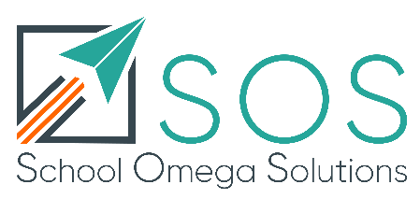
Julie Norman Version 1 05 01 2020

