**Information Required by 8am – Checklist**

|  |  |
| --- | --- |
| **Item** | **Where is it?** |
| School timetable and timings for the school day |  |
| Maps and other practical information |  |
| Access to Wi Fi |  |
| Current staff list (indicating NQTs) |  |
| Any information about previously planned interruptions to normal school routines during the inspection days |  |
| The Single Central Record (SCR) |  |
| Records and analysis of sexual harassment, sexual violence, bullying, discriminatory and prejudiced behaviour either directly or indirectly, records for biphobic and transphobic incidents |  |
| A list of referrals made to the designated safeguarding person and those which were escalated and referred to LA. Brief details of the outcome/resolution should be included. |  |
| A list of all pupils who have open cases with children’s services/social care and for whom there is a multi-agency plan |  |
| Up to date attendance analysis for all groups of pupils |  |
| Documented evidence of the work of those responsible for governance and their priorities including any written scheme of delegation for an academy in a MAT |  |
| A summary of any school self-evaluation or equivalent |  |
| Current school improvement plan, include any plan which sets out longer terms vision for the schools, such as the schools or trust strategy |  |
| Any reports from external evaluation of the school |  |

PRIMARY SCHOOL DAILY TIMETABLE

|  |  |  |  |  |  |  |  |  |  |  |  |  |  |
| --- | --- | --- | --- | --- | --- | --- | --- | --- | --- | --- | --- | --- | --- |
| 8:45 Morning Task | 9:00 | 9:10 – 9:30 | 9:30  -  10:30 | 10:30 | 10:45 – 11:40 | 11:40 – 12:00 | 12:00 – 1:00 | 1:00 – 1:15 | 1:15- 3:10 | | | | 3:10-3:15 |
| Monday | Registration |  |  |  |  |  |  |  |  |  | | | Home Time |
| Tuesday |  |  |  |  | | |  |
| Wednesday |  |  |  |  |  | | |  | |
| Thursday |  |  |  |  |  | | |  |
| Friday |  |  |  |  | | | |

Another Primary School timetable

|  |  |  |  |  |  |  |  |  |  |  |
| --- | --- | --- | --- | --- | --- | --- | --- | --- | --- | --- |
|  | 8.45 – 9.10 | 9.10 – 9.30 | 9.30-10.30am | 10.15  -10.45 | 10.45- 11.10am | 11.10-12pm | 12pm-1.00 | 1-1.20 | 1.15 -2pm | 2-3.05 |
| Monday | Register /morning activity/calendar/timetable |  |  |  |  |  |  |  |  |  |
| Tuesday |  |  |  |  |  |  |
| Wednesday |  |  |  |  |  |  |
| Thursday |  |  |  |  |  |  |
| Friday |  |  |  |  |  |  |

Reception class example

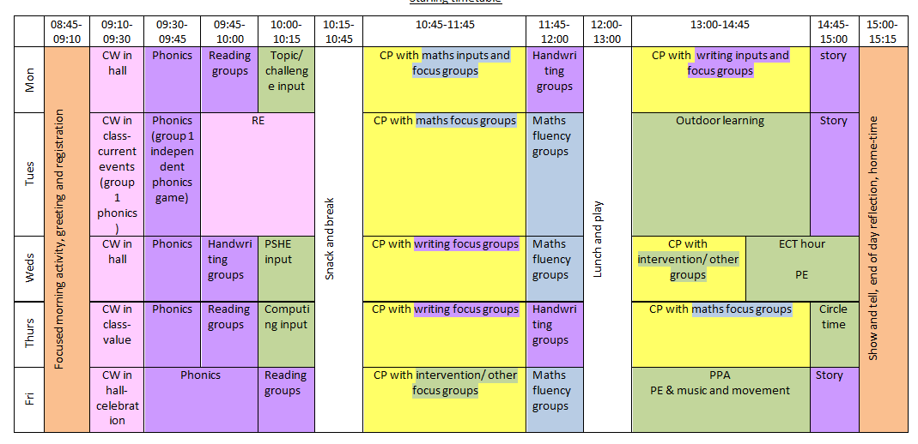

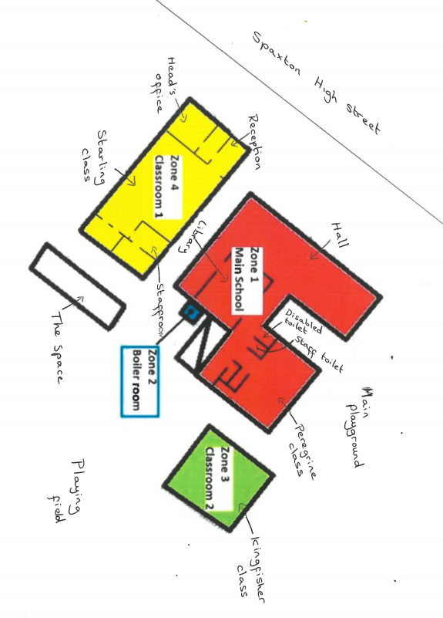

Map and practical details including wi-fi code- !!!!!!!!!!!!!!!!!!!!!

Staff List

Senior Leadership Team

|  |  |  |  |
| --- | --- | --- | --- |
| **Name** | **Role** | **Hours** | **Responsibilities** |
|  |  |  |  |
|  |  |  |  |

Teachers

|  |  |  |  |
| --- | --- | --- | --- |
| **Name** | **Role** | **Hours** | **Responsibilities** |
|  |  |  |  |
|  |  |  |  |
|  |  |  |  |

**Support Staff**

Senior Support Staff

|  |  |  |  |
| --- | --- | --- | --- |
| **Name** | **Role** | **Hours** | **Responsibilities** |
|  |  |  |  |

Support Staff

|  |  |  |  |
| --- | --- | --- | --- |
| **Name** | **Role** | **Hours** | **Responsibilities** |
|  |  |  |  |
|  |  |  |  |
|  |  |  |  |
|  |  |  |  |
|  |  |  |  |
|  |  |  |  |

Other Support Staff (part-time)

|  |  |  |
| --- | --- | --- |
| **Name** | **Role** | **Responsibilities** |
|  |  |  |
|  |  |  |
|  |  |  |
|  |  |  |
|  |  |  |

Any information about previously planned interruptions to normal school routines during the inspection days