Relationships leading to academic achievement.
By Julie Norman, MD School Omega Solutions and Primary Executive Lead BA PGCE NPQH (NPQEL)

A child who is loved, cared for, valued and nurtured are confident, happy and resilient. Nurturing a child’s welling, mental health and healthy relationships comes from small but vital behaviours in school which I will offer you lots of ideas, what we did at my schools, but also how your curriculum, ethos and culture will achieve so much more than you ever thought possible.

A child coming to your school should expect to have 3 healthy relationships for the duration of their education: Parents, Peers and Staff. Each relationship offering opportunities for them to build characteristics that will support them in being a healthy, resilience and ambitious child, keen to learn about themselves, others and the world around them.

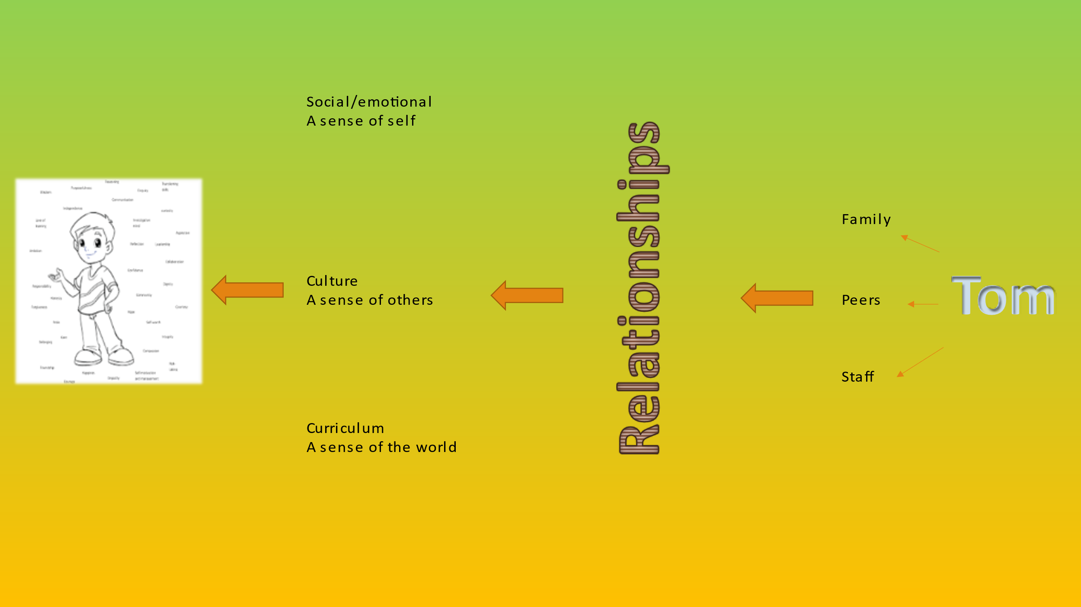

If we want each child to grow and adopt the characteristics needed to become the learner we want them to be, engaged in building their own thoughts and feelings, embracing of others but look for opportunities to change the world for themselves and others. This cannot happen by using their time in school to follow schemes of work, revision for tests or sitting tests. They must be given ample opportunities to grow in character, and as stated, this can happen through relationships.
Some small steps to improve academic achievement in your school through relationships.

Staff
- Praise the child for the smallest of things
- Happy to see him/her - Smile at child when they come in
- Hand on shoulder as you pass
- Wave when you see him/her
- Thank him/her or Apologise to him/her
- Nurture him/her
- Be interested in what he/she says - Listen to him/her
- Value their opinion
- Talk about the child in positive tones knowing they can hear
- Check in on him/her regularly – are you ok?
- Celebrate them often and at every opportunity
- Reassure him when he/she makes social or behaviour mistakes as you would with academic learning
- Help him/her because you want to not because they asked
- Trust them – tell them you trust them, often

Parents – support parents to offer these:
- Unconditional love, they forgive quickly - Forgiveness every time
- Know his/her gifts/talents
- Understand him/her
- Reassure him/her that they are supported
- Listen to him/her
- Champion him/her privately and publicly
- Praise him/her privately and publicly
- Like them and they know they are liked and loved
- Talk about him/her positively so he/she can hear it
- Nurture him/her
- Basic needs are met

Peers – encourage friends to offer these:
- Loyalty – prearranged group tasks, peer assessment, ambassadors
- Friendship – adult support in the playground and play leaders
- Challenge – time to talk and debate in class
- Forgiveness – ELSA group support to resolve issues
- Accountability – encourage children to help each other
- Compromise – in class all the time when making decisions
- Debate – debate group and hot topics for discussion in assembly
- Equality – assemblies / visitors
- Laughter – time for them to play and have fun
- Fun – make time for fun in school

Maslow before Blooms!
Always ensure basic needs are met before expecting high academic achievement.

Help the child to learn a sense of self:-
- Give them responsibilities
- Give them Leadership opportunities,
- Self growth opportunities,
- Input into their learning
- Give them time to share their ideas
- Give them a voice in the school – they can write the school policies!
- Let them make changes
- Give them chances to work on projects that have a huge impact in their community
- Give them a chance to fail, followed up by reflection and celebration
- Let them have the time to speak to others about their achievements – be an ambassador for the school

Sense of others
- Give them a chance to help others as part of a team of ambassadors
- Give them responsibilities around other people
- Give them time to get to know others – mixed social events
- Give them opportunities to support other people and celebrate their achievements
- Help them to learn about the people around them
- Help them to gain empathy and understanding of all events affecting others
- Give them time to work on charity work
- Let them be a mentor /coach

Sense of the world
- Let them participate in their learning journey by planning with you
- Create a curriculum with projects they can help to plan and execute with real outcomes for the world
- Help them to make the world a better place – reality and purpose
- Teach them how to be a global citizen
- Help them to be confident online and use it to communicate with the world
- Help them carve their place in the world before they leave school – know where their strengths are needed and valued.

If the child receives these relationships and opportunities throughout school they will be able to grow in the characteristics of:
Courage, happiness, empathy, self-motivation and management, risk-taking, compassion, integrity, self-worth, courtesy, hope, community, dignity, confidence, collaboration, reflection, leadership, aspiration, investigative mind, curiosity, transferring skills, enquiry, communication, reasoning, purposefulness, independence, love of learning, wisdom, ambition, responsibility, honesty, forgiveness, pride, care, belonging and friendship….to name but a few.
Bigger steps you can take:
If, like my schools, you want to give much more opportunities for the children to grow in characteristics without it being yet another bolt-on to remember, change your curriculum to a Character Curriculum. This ensures progression, relevance and time to consolidate.
You can take the radical move to merging your subjects into projects!
We set projects each term that were relevant for today, opportunities for children to join in the conversation, learn about the topics being discussed in life and being part of its celebration or change. Children became part of society and school just facilitated that and guided it.
So where do you begin?
Well, you can firstly list all the characteristics, then look to create a progression from YR – Y6 as you would any subject matter. Then pool your objectives for each year group for every subject. Combine the year group objectives (for all subjects together) along with the characteristics and look to topical subjects such as climate change, black lives matter, single use plastic, democracy, or whatever is being discussed and place at least a third of the year’s objectives into that project. We found we covered far more objectives through the year by teaching like this. Alongside that you will need visitors, visits out or anything else that enhances the learning and completing of the project.
How do the children take control?
Project based, Loops of learning or S plans blended with Blooms Taxonomy.
Allow the children to decide what they want to achieve at the end of the project in consultation with the teacher. They then discuss their strengths and weaknesses as a group look at ways to mitigate those.
Why did we do this? Well, we wanted children to enjoy school and see real purpose in being there. Attendance went up to 98% and we found that they were only out when we told them to be for 48hrs due to D&V. We wanted them to take more responsibility for their learning and with the projects they became passionate, collaborative and took control. Now the teacher was working 20% and the children were working 80% of the time. Workload for teachers hit an all time low and children started to go home tired – result! We also wanted children to be prepared for the next stage in their life whether that be the next year group or their next school and this way of teaching did create very informed and confident children.
Academic achievement:
There is no doubt with these big changes the children’s achievements rose considerably, more children gained greater depth as all learning was purposeful, but even more interesting is our SEND children engaged and made outstanding progress as well as our PP children where 100% made expected or above expected progress.
In a nutshell:
- Whether you go for the Character Curriculum or Creative Curriculum or other – it is vital children are involved in the planning and delivery of it. Usually project based allows for real life purpose and sees the desired outcome being a real measured change in their community or the world that they can attribute their name to. Review if your curriculum meets your desired outcome (Intent). If not then instead of changing your intent, just change your curriculum!
- Begin to share with the children the characteristics they may want to adopt and explicitly speak of them daily – celebrate where you see them and where you are working on them.
- Begin to allow the children to manage marketing and PR. They can write the articles they want to send out to the community to know about or draw them in to their cause as well as radio interviews.
- The children to write the policies that affect them such as marking/feedback, curriculum policy, behaviour and many more.

If you would like support in any of these areas or more information you can contact me on www.schoolomegasolutions.co.uk or julie@schoolomegasolutions.co.uk or 01172440119

